1. Introduction to Data Structures (10 Points)
- A Data Structure is a way of organizing and storing data in a computer.
- It helps to store, access, and manage data efficiently.
- Data structures improve program performance and memory usage.
- They allow efficient searching, insertion, deletion, and sorting of data.
- Data structures are mainly divided into Linear and Non-Linear structures.
- Linear structures store elements sequentially (Array, Linked List, Stack, Queue).
- Non-Linear structures store elements hierarchically (Tree, Graph).
- Data structures are also classified as Static and Dynamic structures.
- Static structures have fixed size (Array), while Dynamic structures can grow or shrink (Linked List).
- Data structures are widely used in databases, operating systems, networking, and AI applications.

2. Algorithm Design (10 Points)
- An Algorithm is a step-by-step procedure to solve a problem.
- It must have clear input and output.
- An algorithm should be finite, meaning it must end after a number of steps.
- Each step must be well defined and unambiguous.
- Algorithms should be efficient in time and memory usage.
- They are usually written using pseudocode or flowcharts.
- Good algorithm design helps in solving complex problems systematically.
- Algorithms are analyzed using time complexity and space complexity.
- Examples include searching algorithms and sorting algorithms.
- Algorithm design is important in software development and problem solving.

3. Algorithm Design Paradigms – Motivation (10 Points)
- Algorithm design paradigms are general approaches used to design algorithms.
- They provide systematic methods to solve computational problems.
- Paradigms help in breaking complex problems into smaller manageable parts.
- They improve efficiency and structure of algorithms.
- Common paradigms include Divide and Conquer, Greedy, Dynamic Programming, and Backtracking.
- Divide and Conquer divides a problem into smaller subproblems.
- Greedy method makes the best choice at each step.
- Dynamic Programming solves problems by storing results of subproblems.
- Backtracking tries all possible solutions and selects the correct one.
- Using design paradigms helps developers create optimized and reusable algorithms.
1. Concept of Algorithmic Efficiency (10 Points)
- Algorithmic efficiency measures how well an algorithm uses time and memory.
- It helps determine which algorithm performs better for a problem.
- Efficiency is mainly measured using Time Complexity and Space Complexity.
- Time Complexity represents how long an algorithm takes to run.
- Space Complexity represents how much memory an algorithm uses.
- Efficient algorithms solve problems faster with fewer resources.
- Efficiency becomes important when handling large amounts of data.
- Algorithms can have best case, average case, and worst case performance.
- Developers compare algorithms based on their growth rate with input size.
- Choosing an efficient algorithm improves system performance and scalability.

2. Run Time Analysis of Algorithms (10 Points)
- Run time analysis studies how the running time of an algorithm changes with input size.
- It helps estimate performance before implementing the algorithm.
- Running time is usually expressed as a function of input size (n).
- It focuses on number of basic operations executed.
- Run time analysis considers best case, average case, and worst case scenarios.
- Worst case analysis is commonly used to guarantee performance.
- It ignores constant factors and lower order terms.
- Helps compare different algorithms solving the same problem.
- Run time is often represented using asymptotic notation.
- It helps programmers select the most efficient algorithm.

3. Asymptotic Notations (10 Points)
- Asymptotic notations describe the growth rate of an algorithm’s running time.
- They show performance when input size becomes very large.
- They ignore constant values and smaller terms.
- The most common notation is Big O (O).
- Big O notation represents the upper bound or worst case of an algorithm.
- Omega (Ω) notation represents the lower bound or best case.
- Theta (Θ) notation represents the tight bound (average case).
- Common complexities include O(1), O(log n), O(n), O(n log n), O(n²).
- Asymptotic notation helps compare algorithms independently of hardware.
- It is widely used in algorithm design and performance analysis.
1. Recurrences (10 Points)
- A recurrence relation defines the running time of a recursive algorithm.
- It expresses T(n) in terms of smaller inputs like T(n-1), T(n/2) etc.
- Recurrences commonly appear in divide and conquer algorithms.
- They help analyze the time complexity of recursive programs.
- Example recurrence:
T(n)=2T(n/2)+n
- This means the problem of size n is divided into 2 subproblems of size n/2.
- Recurrences are solved using Substitution Method, Recursion Tree Method, and Master Method.
- These methods help find the asymptotic time complexity.
- Recurrences simplify the analysis of recursive algorithms.
- They are widely used in algorithms like Merge Sort, Quick Sort, and Binary Search.

2. Substitution Method (10 Points)
- The Substitution Method is used to solve recurrence relations.
- In this method, we guess the solution first.
- Then we prove the guess using mathematical induction.
- It involves replacing the recurrence repeatedly with smaller values.
- The goal is to show that the solution satisfies the recurrence.
- Example recurrence:
T(n)=T(n-1)+n
- Assume a solution such as T(n) = O(n²).
- Substitute the assumption into the recurrence.
- Verify whether the assumption satisfies the equation.
- If correct, the guessed complexity becomes the final solution.

3. Recursion Tree Method (10 Points)
- The Recursion Tree Method represents the recurrence as a tree structure.
- Each node in the tree represents the cost of a recursive call.
- The root represents the original problem size n.
- Child nodes represent smaller subproblems.
- Example recurrence:
T(n)=2T(n/2)+n
- The tree expands until reaching the base case.
- We calculate the cost at each level of the tree.
- Then we sum the cost of all levels.
- This gives the total running time of the algorithm.
- This method is useful for understanding divide and conquer algorithms.

4. Master Method (10 Points)
- The Master Method provides a direct formula to solve recurrences.
- It is used mainly for divide and conquer algorithms.
- The general recurrence form is:
T(n)=aT(n/b)+f(n)
- Here a = number of subproblems.
- b = factor by which problem size is divided.
- f(n) = cost of dividing and combining the problem.
- The method compares f(n) with n^{\log_b a}.
- Based on comparison, there are three cases in the Master Theorem.
- It quickly gives the time complexity without expanding recurrence.
- It is commonly used for algorithms like Merge Sort and Binary Search.
1. Arrays – Implementation and Analysis of Basic Operations (10 Points)
- Array is a collection of elements of the same type stored in contiguous memory locations.
- Arrays can be 1D, 2D, or multi-dimensional.
- Elements in an array are accessed using indices starting from 0.
- Insertion at the end: O(1), at a specific position: O(n).
- Deletion from the end: O(1), from a specific position: O(n).
- Traversal of an array to access all elements: O(n).
- Search for an element: O(n) for linear search, O(log n) for binary search (sorted array).
- Arrays are static in size (fixed length).
- Memory allocation can be static (compile-time) or dynamic (run-time).
- Arrays are widely used in sorting, searching, and implementing other data structures.

2. Stack – Implementation and Analysis of Push and Pop Operations (10 Points)
- Stack is a linear data structure that follows LIFO (Last In, First Out).
- Two main operations: Push (insert) and Pop (delete).
- Push operation adds an element at the top of the stack.
- Pop operation removes the top element from the stack.
- Stacks can be implemented using arrays or linked lists.
- Push and Pop operations take O(1) time in both array and linked list implementations.
- Overflow occurs if a push is done on a full stack.
- Underflow occurs if a pop is done on an empty stack.
- Stack also supports Peek/Top operation to see the top element in O(1).
- Stacks are used in expression evaluation, recursion, backtracking, and undo mechanisms.
Infix, Postfix, and Prefix Expressions (10 Points)
- Infix Expression: Operator is written between operands (e.g., A + B).
- Postfix Expression (Reverse Polish Notation): Operator is written after operands (e.g., A B +).
- Prefix Expression (Polish Notation): Operator is written before operands (e.g., + A B).
- Infix is easiest for humans to read but requires parentheses and operator precedence for evaluation.
- Postfix does not need parentheses and is easier for computers to evaluate using a stack.
- Prefix also does not require parentheses and can be evaluated using a stack from right to left.
- Conversion between expressions is done using stack-based algorithms.
- Evaluation of postfix: Scan left to right, push operands, pop for operator, push result.
- Evaluation of prefix: Scan right to left, push operands, pop for operator, push result.
- Commonly used in compilers, calculators, and expression parsing.
Queue – Implementation and Analysis of Basic Operations (10 Points)
- Queue is a linear data structure that follows FIFO (First In, First Out).
- Elements are inserted at the rear (enqueue) and removed from the front (dequeue).
- Basic operations of a queue: Enqueue, Dequeue, Front/Peek, isEmpty, isFull.
- Enqueue operation adds an element at the rear of the queue.
- Dequeue operation removes an element from the front of the queue.
- Queues can be implemented using arrays or linked lists.
- Enqueue and Dequeue operations take O(1) time in a linked list implementation.
- In array implementation, care is needed for overflow and circular queue to reuse space.
- Front/Peek operation allows viewing the front element in O(1) time.
- Queues are widely used in CPU scheduling, printer spooling, BFS in graphs, and buffering.
Circular Queue and Its Analysis (10 Points)
- Circular Queue is a linear data structure where the last position is connected back to the first, forming a circle.
- It overcomes the wasted space problem of a simple linear queue.
- Elements are inserted at the rear (enqueue) and removed from the front (dequeue).
- Front and rear pointers are used to track the positions.
- Enqueue operation: (rear + 1) % size to insert element at the correct position.
- Dequeue operation: (front + 1) % size to remove element and update front.
- Circular queue can be implemented using arrays or linked lists.
- Time complexity: Enqueue O(1), Dequeue O(1), Peek O(1).
- Space complexity: O(n) for n elements; no space is wasted unlike linear array queues.
- Circular queues are used in CPU scheduling, traffic systems, buffering, and resource management.
- 1. Array – Basic Operations
public class ArrayExample {
public static void main(String[] args) {
int[] arr = {10, 20, 30, 40, 50};
// Traversal
System.out.println("Array elements:");
for(int num : arr){
System.out.print(num + " ");
}
// Access element at index 2
System.out.println("\nElement at index 2: " + arr[2]);
}
}

2. Stack – Push and Pop
import java.util.Stack;
public class StackExample {
public static void main(String[] args) {
Stack<Integer> stack = new Stack<>();
stack.push(10);
stack.push(20);
stack.push(30);
System.out.println("Stack: " + stack);
int popped = stack.pop();
System.out.println("Popped: " + popped);
System.out.println("Stack after pop: " + stack);
}
}
3. Infix, Postfix, Prefix (Simple Postfix Evaluation)
import java.util.Stack;
public class PostfixExample {
public static void main(String[] args) {
String expr = "23+5*"; // (2+3)*5
Stack<Integer> stack = new Stack<>();
for(char c : expr.toCharArray()) {
if(Character.isDigit(c)) {
stack.push(c - '0');
} else {
int b = stack.pop();
int a = stack.pop();
if(c == '+') stack.push(a + b);
if(c == '-') stack.push(a - b);
if(c == '*') stack.push(a * b);
if(c == '/') stack.push(a / b);
}
}
System.out.println("Result: " + stack.pop());
}
}
4. Queue – Basic Operations
import java.util.LinkedList;
import java.util.Queue;

public class QueueExample {
public static void main(String[] args) {
Queue<Integer> queue = new LinkedList<>();
queue.add(10);
queue.add(20);
queue.add(30);
System.out.println("Queue: " + queue);
int removed = queue.remove();
System.out.println("Removed: " + removed);
System.out.println("Queue now: " + queue);
}
}
5. Circular Queue – Easy Version
public class CircularQueue {
int[] arr = new int[5];
int front = -1, rear = -1, size = 5;
void enqueue(int val) {
if ((rear + 1) % size == front) {
System.out.println("Queue Full");
return;
}
if (front == -1) front = 0;
rear = (rear + 1) % size;
arr[rear] = val;
}

void dequeue() {
if (front == -1) {
System.out.println("Queue Empty");
return;
}
System.out.println("Removed: " + arr[front]);
if (front == rear) front = rear = -1;
else front = (front + 1) % size;
}
void display() {
if (front == -1) { System.out.println("Queue Empty"); return; }
System.out.print("Queue: ");
int i = front;
while(true){
System.out.print(arr[i] + " ");
if(i == rear) break;
i = (i + 1) % size;
}
System.out.println();
}
public static void main(String[] args) {
CircularQueue cq = new CircularQueue();
cq.enqueue(10); cq.enqueue(20); cq.enqueue(30);
cq.display();
cq.dequeue(); cq.display();
cq.enqueue(40); cq.enqueue(50); cq.enqueue(60);
cq.display();
}
}
END SEM --------------------------------------------------------------------END SEM
1️⃣ Singly Linked List: Insertion & Deletion
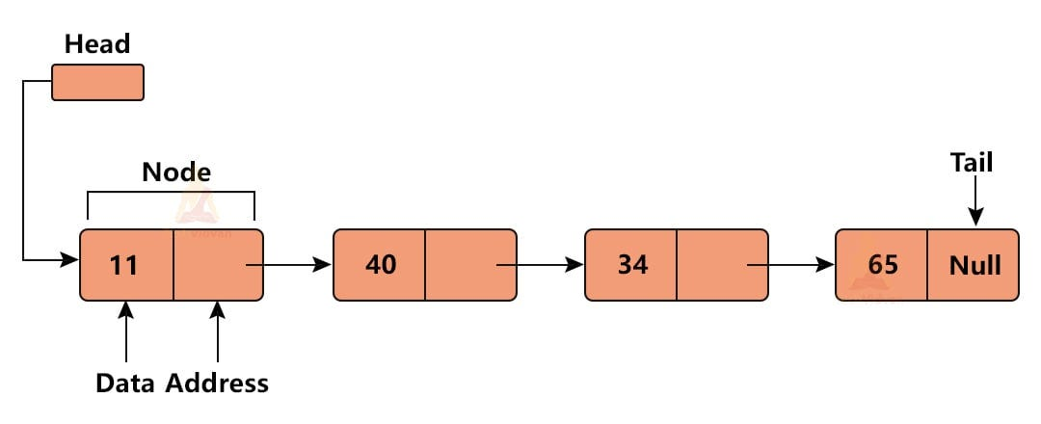
✅ 10 Points
- A singly linked list is a linear data structure of nodes.
- Each node contains data + next pointer.
- First node is called head.
- Insertion can be done at beginning, middle, end.
- Insertion at beginning is O(1).
- Insertion at end is O(n).
- Deletion removes a node and updates pointers.
- Deletion at beginning is O(1).
- Deletion at end is O(n).
- Memory is dynamic (no fixed size).
📌 Example
Insert 10 → 20 → 30
After inserting 5 at beginning:
👉 5 → 10 → 20 → 30
Delete 20:
👉 5 → 10 → 30
🌍 Real-Life Example
- Train compartments connected one after another
- Removing a coach = deletion
📊 Diagram
[10 | *] → [20 | *] → [30 | NULL]

2️⃣ Doubly Linked List: Operations
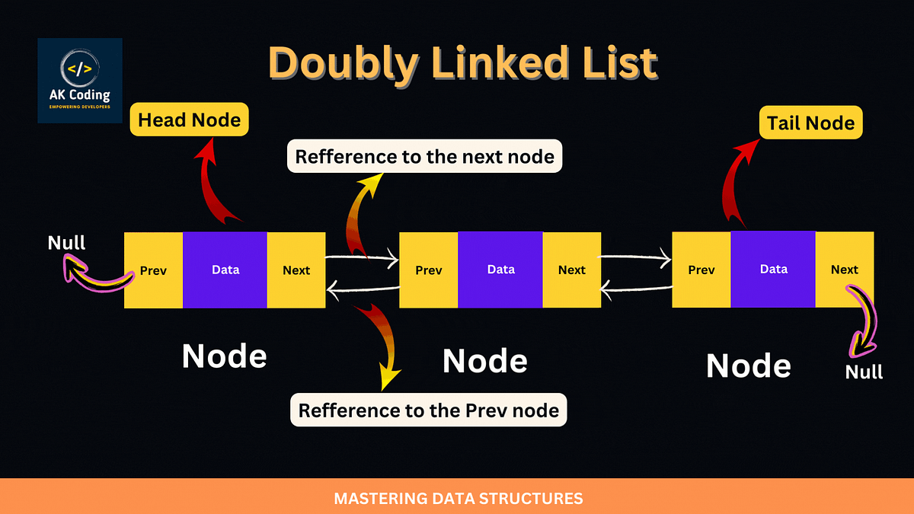
✅ 10 Points
- Each node has prev + data + next.
- Traversal possible in both directions.
- First node → prev = NULL.
- Last node → next = NULL.
- Insertion at beginning is O(1).
- Insertion at end is O(n).
- Deletion updates both pointers.
- More memory used than singly list.
- Easier deletion compared to singly list.
- Useful for navigation systems.
📌 Example
10 ⇄ 20 ⇄ 30
Insert 15 after 10:
👉 10 ⇄ 15 ⇄ 20 ⇄ 30
🌍 Real-Life Example
- Browser forward/back buttons
📊 Diagram
NULL ← [10] ⇄ [20] ⇄ [30] → NULL

3️⃣ Binary Search Tree (BST)
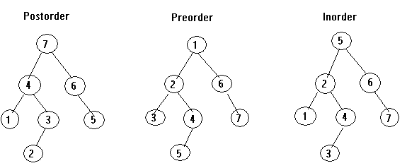
✅ 10 Points
- A tree where left < root < right.
- Each node has at most 2 children.
- Insertion follows BST property.
- Searching is efficient.
- Average time complexity = O(log n).
- Worst case = O(n).
- Inorder traversal gives sorted data.
- Supports insertion, deletion, search.
- Used in databases & indexing.
- Dynamic structure.
📌 Example
Insert: 50, 30, 70, 20
50
/ \
30 70
/
20
🌍 Real-Life Example
- Phone contact search (alphabetical order)

4️⃣ Construct BST from Traversals
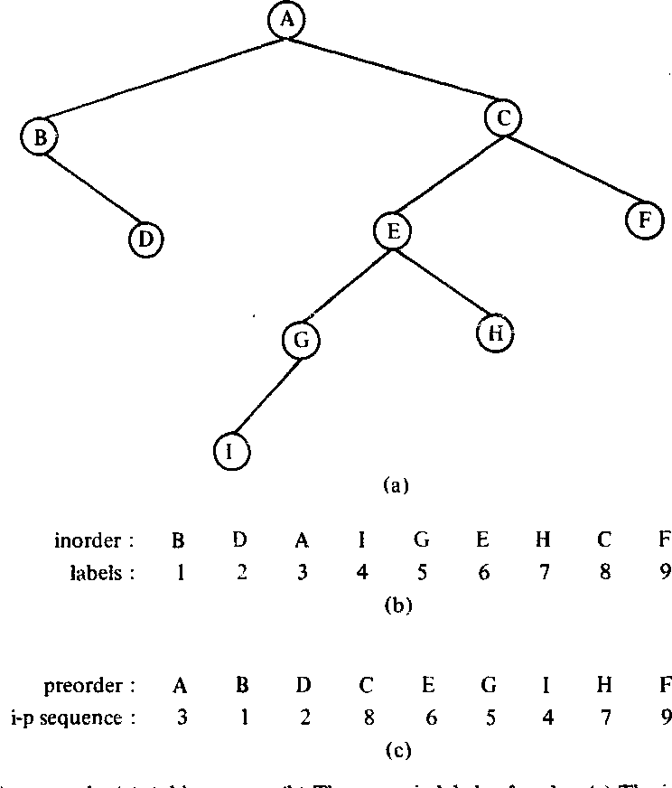
✅ 10 Points
- Infix = Inorder traversal.
- Preorder = Root first.
- Postorder = Root last.
- Use preorder/postorder to identify root.
- Use inorder to split left & right.
- Recursively construct tree.
- Left side = left subtree.
- Right side = right subtree.
- Works for unique elements.
- Time complexity = O(n).
📌 Example
Inorder: D B E A F C
Preorder: A B D E C F
Tree:
A
/ \
B C
/ \ /
D E F
🌍 Real-Life Example
- Reconstructing folder structure from traversal logs

5️⃣ AVL Tree (Self-Balancing BST)

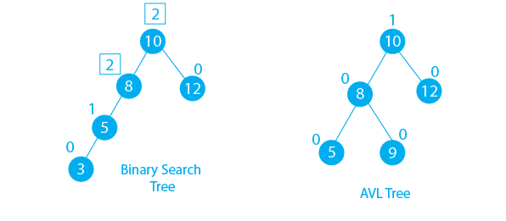
✅ 10 Points
- AVL tree is a balanced BST.
- Balance factor = height(left) − height(right).
- Value must be −1, 0, or 1.
- If unbalanced → rotations required.
- Types: LL, RR, LR, RL rotations.
- Insertion maintains balance.
- Deletion also rebalances tree.
- Search time = O(log n).
- Faster than BST in worst case.
- Used in databases & memory systems.
📌 Example
Insert: 10, 20, 30
Unbalanced:
10 → 20 → 30
After rotation:
20
/ \
10 30
🌍 Real-Life Example
- Database indexing systems (fast search)

1️⃣ Introduction & Sequential Representation (Adjacency / Path Matrix)
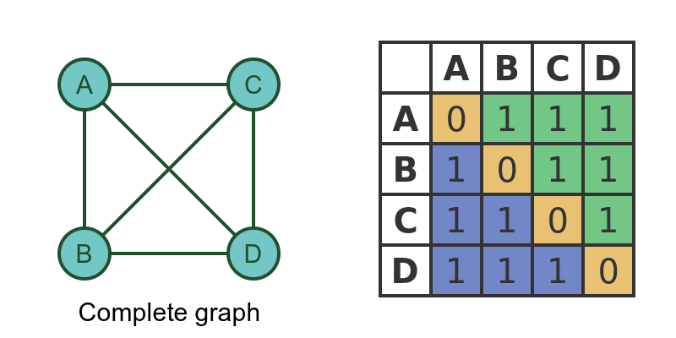
✅ 10 Points (Full Sentences)
- A graph is a non-linear data structure consisting of vertices and edges.
- Vertices represent nodes, and edges represent connections between them.
- Graphs can be directed or undirected.
- Sequential representation of a graph is done using matrices.
- An adjacency matrix stores whether an edge exists between two vertices.
- If there is an edge, the value is 1; otherwise, it is 0.
- A path matrix shows reachability between vertices.
- The size of the matrix is n × n, where n is the number of vertices.
- Adjacency matrix is easy to implement but consumes more memory.
- It is suitable for dense graphs.
📌 Example
Vertices: A, B, C
Adjacency Matrix:
A B C
A 0 1 1
B 1 0 0
C 1 0 0
🌍 Real-Life Example
A graph can represent a social network where users are vertices and friendships are edges.

2️⃣ Warshall Algorithm & Linked Representation

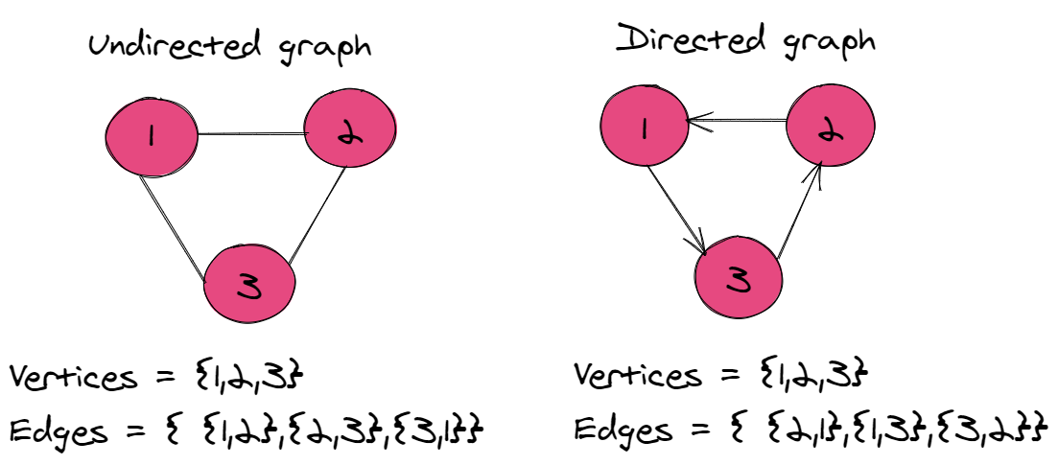

✅ 10 Points (Full Sentences)
- Warshall algorithm is used to find the transitive closure of a graph.
- It determines whether a path exists between all pairs of vertices.
- It uses a matrix-based approach.
- It updates the matrix using intermediate vertices.
- The time complexity of Warshall algorithm is O(n³).
- Linked representation uses adjacency lists.
- Each vertex stores a list of its adjacent vertices.
- It is memory efficient compared to adjacency matrix.
- It is suitable for sparse graphs.
- It allows easy traversal of neighbors.
📌 Example
Graph: A → B → C
Path matrix after Warshall:
A → C becomes reachable
🌍 Real-Life Example
Warshall algorithm is used in routing systems to check connectivity between all locations.
📊 Diagram
A → B → C

3️⃣ Graph Traversals: DFS and BFS
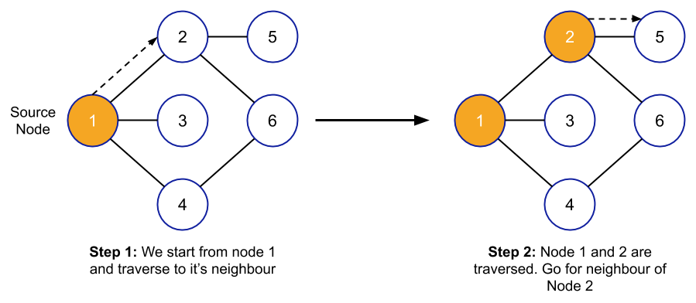
✅ 10 Points (Full Sentences)
- Graph traversal is the process of visiting all vertices of a graph.
- Depth First Search (DFS) explores as far as possible before backtracking.
- DFS uses a stack or recursion.
- Breadth First Search (BFS) explores level by level.
- BFS uses a queue data structure.
- DFS is useful for path finding and cycle detection.
- BFS is useful for shortest path in unweighted graphs.
- Time complexity of both is O(V + E).
- Traversal ensures all nodes are visited once.
- Both algorithms are fundamental in graph theory.
📌 Example
Graph: A → B, A → C
DFS: A → B → C
BFS: A → B → C
🌍 Real-Life Example
DFS is like exploring a maze deeply, while BFS is like finding the shortest path in Google Maps.

4️⃣ Spanning Trees: Representation and Construction
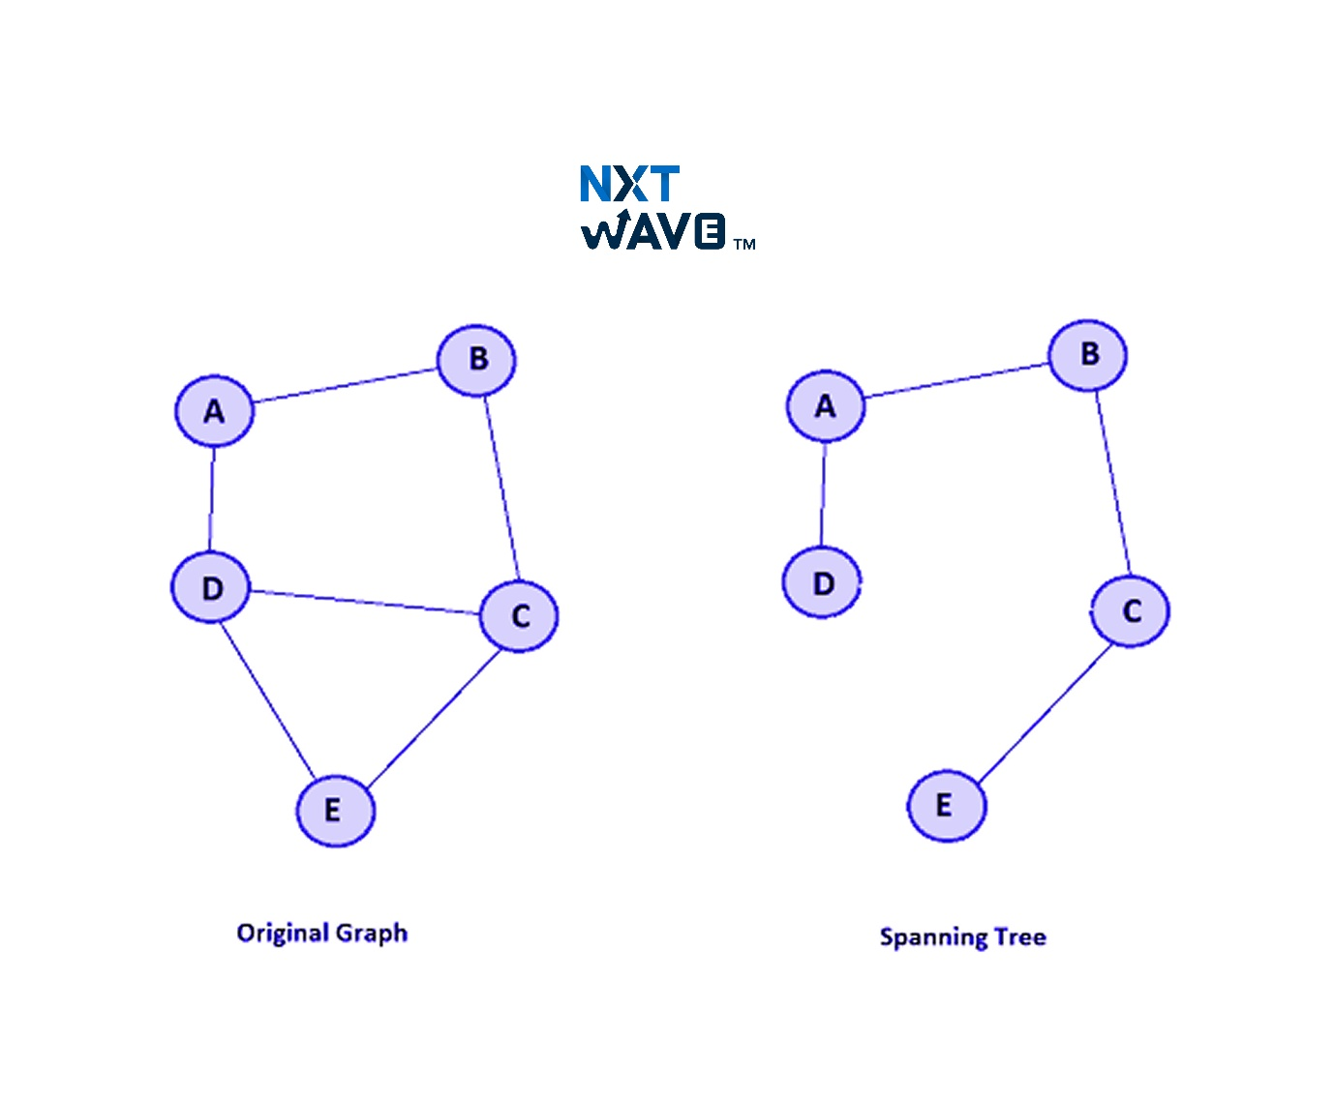
✅ 10 Points (Full Sentences)
- A spanning tree is a subgraph that includes all vertices of the graph.
- It contains exactly n−1 edges for n vertices.
- It does not contain any cycles.
- A graph can have multiple spanning trees.
- It connects all vertices with minimum edges.
- It is derived from a connected graph.
- It can be constructed using DFS or BFS.
- It maintains connectivity of the graph.
- It is used in network design.
- It simplifies graph structure.
📌 Example
Graph with 4 vertices → spanning tree has 3 edges.
🌍 Real-Life Example
Spanning trees are used in designing electrical networks to connect all houses with minimum wiring.
📊 Diagram
Graph: Tree:
A-B-C A-B-C
\ | |
D D

5️⃣ Minimum Spanning Tree (Prim’s & Kruskal’s)
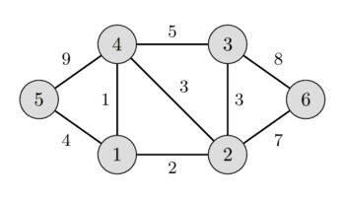

✅ 10 Points (Full Sentences)
- A Minimum Spanning Tree (MST) is a spanning tree with minimum total edge weight.
- It connects all vertices with the least cost.
- Prim’s algorithm builds MST by selecting minimum edge from a vertex.
- It grows the tree step by step.
- Kruskal’s algorithm selects the smallest edge globally.
- It avoids cycles while adding edges.
- Kruskal uses sorting of edges.
- Prim uses priority queue or greedy approach.
- Time complexity varies based on implementation.
- MST is used in network optimization.
📌 Example
Edges: A-B (1), B-C (2), A-C (3)
MST = A-B + B-C (total = 3)
🌍 Real-Life Example
MST is used in laying cables or roads with minimum cost.
📊 Diagram
A
/ \
1 3
/ \
B---2---C

MST:
A---B---C
Got it 👍 — 5–6 words per point, clean exam format

1️⃣ Divide & Conquer: Binary Search, Merge Sort, Quick Sort
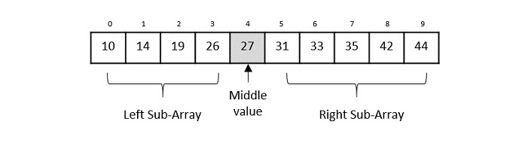
✅ 10 Points
- Divide problem into smaller independent subproblems
- Solve each subproblem using recursion
- Combine subproblem results for final solution
- Binary Search works only on sorted arrays
- Repeatedly divides array into two halves
- Time complexity of Binary Search O(log n)
- Merge Sort uses divide and merge technique
- Merge Sort guarantees stable sorting output
- Quick Sort selects pivot and partitions array
- Quick Sort average time complexity O(n log n)
📌 Example
Binary Search → find 30 in sorted array
🌍 Real-Life
Searching word quickly in large dictionary
📊 Diagram
[10 20 30 40]
↑ mid

2️⃣ Heap Sort, Strassen Multiplication, Recurrence Analysis
✅ 10 Points
- Heap Sort uses binary heap structure
- Convert array into max heap form
- Root node always contains largest element
- Swap root with last element repeatedly
- Apply heapify to maintain heap property
- Heap Sort time complexity O(n log n)
- Strassen algorithm improves matrix multiplication speed
- Reduces number of multiplication operations significantly
- Recurrence analysis solves recursive time equations
- Methods include substitution, recursion tree, master theorem
📌 Example
Max Heap:
50
/ \
30 40
🌍 Real-Life
Task scheduling using priority queue system

1️⃣ Greedy Method: Fractional Knapsack & Job Sequencing


✅ 10 Points
- Greedy method selects best local choice
- Does not reconsider previous decisions later
- Suitable for optimization problems efficiently
- Fractional knapsack allows breaking items
- Items sorted by value to weight ratio
- Pick highest ratio items first
- Maximizes total profit within capacity
- Job sequencing schedules tasks with deadlines
- Select jobs with maximum profit first
- Assign jobs within available time slots

📌 Example
Knapsack capacity = 50
Items → (value, weight) = (60,10), (100,20), (120,30)
Select highest ratio → maximum profit achieved
Job Sequencing → Jobs with deadlines & profits → schedule highest profit jobs first

🌍 Real-Life
Selecting most profitable projects under time

📊 Diagram
Knapsack:
[Item1] [Item2] [Item3]
↓ ↓ ↓
Highest value/weight first

Job Slots:
Time → [1] [2] [3]
Jobs → J2 J1 J3

1️⃣ Single Source Shortest Paths & Huffman Coding
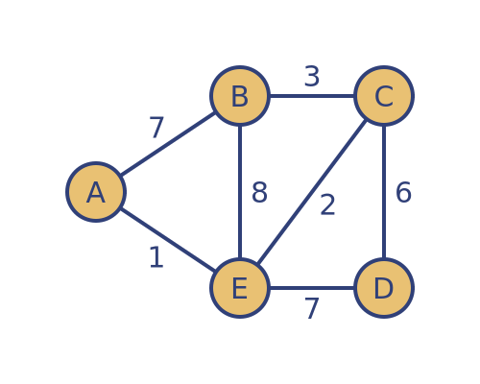✅ 10 Points
- Single source shortest path finds minimum distances
- Computes shortest path from one source vertex
- Dijkstra algorithm commonly used for solution
- Works only with non-negative edge weights
- Selects minimum distance vertex at each step
- Updates distance of all adjacent neighbors
- Huffman coding used for data compression
- Based on frequency of characters occurrence
- Builds binary tree with minimum cost
- Produces optimal prefix-free binary codes

📌 Example
Shortest Path:
A → B (1), B → C (2) → A to C = 3
Huffman Coding:
Characters → A(5), B(9), C(12) → build tree

🌍 Real-Life
Google Maps shortest route, file compression

📊 Diagram
Shortest Path:
A --1--> B --2--> C

Huffman Tree:
(*)
/ \
A(5) (*)
/ \
B(9) C(12)

1️⃣ Dynamic Programming: Difference & Matrix Chain Multiplication
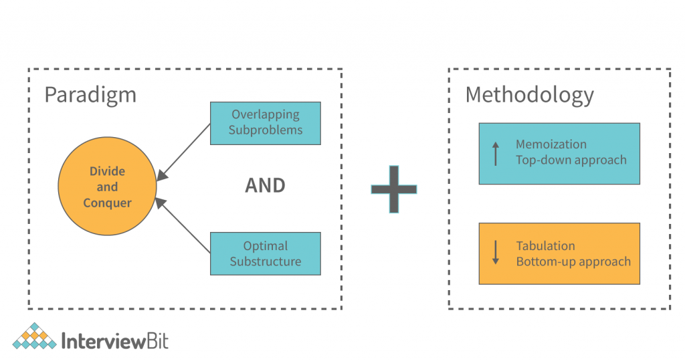
✅ 10 Points
- Dynamic programming stores results for reuse
- Avoids repeated calculations using memoization
- Uses overlapping subproblems property efficiently
- Uses optimal substructure property for solution
- Divide and conquer solves independent subproblems
- DP stores results, divide and conquer does not
- DP uses tabulation or memoization methods
- Matrix chain multiplication finds optimal order
- Minimizes total number of multiplications
- Uses DP table for storing intermediate results

📌 Example
Matrices: A(10×20), B(20×30), C(30×40)
Best order → (A×B)×C or A×(B×C) → choose minimum cost

🌍 Real-Life
Optimizing sequence of operations in computing

📊 Diagram
A(10×20) B(20×30) C(30×40)

(A×B)×C OR A×(B×C)
Choose minimum multiplication cost

1️⃣ Traveling Salesman Problem & All-Pairs Shortest Path
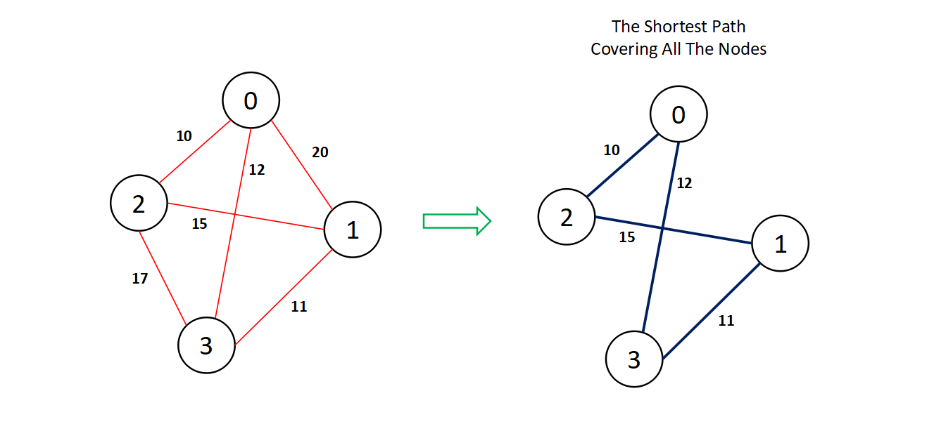
✅ 10 Points
- Traveling salesman visits all cities once
- Returns back to starting city
- Goal is minimum total travel cost
- It is NP-hard optimization problem
- Solved using dynamic programming approach
- All-pairs shortest path finds all distances
- Floyd-Warshall algorithm commonly used solution
- Uses adjacency matrix for graph representation
- Updates paths using intermediate vertices repeatedly
- Time complexity of algorithm is O(n³)

📌 Example
TSP → A → B → C → A minimum cost path
All-Pairs → find shortest path between every node

🌍 Real-Life
Delivery route optimization and network routing

📊 Diagram
TSP:
A → B → C → A

All-Pairs Matrix:
A B C
A 0 1 3
B 1 0 2
C 3 2 0
------------------------------CODE------------------------------------------------
Singly Linked List: Insertion and deletion operations and analysis
class Node {
int data;
Node next;
Node(int d) { data = d; }
}
public class Main {
static Node head;
static void insert(int x) {
Node n = new Node(x);
n.next = head;
head = n;
}
static void delete() {
if (head != null) head = head.next;
}
static void print() {
Node t = head;
while (t != null) {
System.out.print(t.data + " ");
t = t.next;
}
}
public static void main(String[] args) {
insert(10);
insert(20);
insert(30);
print();
delete();
print();
}
}
Doubly Linked List: Basic operations and analysis
class Node {
int data;
Node prev, next;
Node(int d) { data = d; }
}
public class Main {
static Node head;
static void insert(int x) {
Node n = new Node(x);
if (head != null) head.prev = n;
n.next = head;
head = n;
}
static void delete() {
if (head != null) {
head = head.next;
if (head != null) head.prev = null;
}
}
static void print() {
Node t = head;
while (t != null) {
System.out.print(t.data + " ");
t = t.next;
}
}
public static void main(String[] args) {
insert(10);
insert(20);
insert(30);
print();
delete();
print();
}
}
Binary Search Tree (BST): Implementation and Operations
class Node {
int data;
Node left, right;
Node(int d) { data = d; }
}
public class Main {
static Node root;
static Node insert(Node root, int x) {
if (root == null) return new Node(x);
if (x < root.data) root.left = insert(root.left, x);
else root.right = insert(root.right, x);
return root;
}
static boolean search(Node root, int x) {
if (root == null) return false;
if (root.data == x) return true;
if (x < root.data) return search(root.left, x);
return search(root.right, x);
}
static void inorder(Node root) {
if (root != null) {
inorder(root.left);
System.out.print(root.data + " ");
inorder(root.right);
}
}
public static void main(String[] args) {
root = insert(root, 50);
insert(root, 30);
insert(root, 70);
insert(root, 20);
insert(root, 40);
inorder(root);
System.out.println();
System.out.println(search(root, 40));
}
}
Constructing BST from Infix and Pre/Post fix order
class Node{
char d; Node l,r;
Node(char x){ d=x; }
}

class Main{
static int i=0;
static Node build(char[] in,char[] pre,int s,int e){
if(s>e) return null;
Node n=new Node(pre[i++]);
int k=s;
while(in[k]!=n.d) k++;
n.l=build(in,pre,s,k-1);
n.r=build(in,pre,k+1,e);
return n;
}
static void post(Node r){
if(r!=null){
post(r.l); post(r.r);
System.out.print(r.d+" ");
}
}
public static void main(String[] a){
char[] in={'D','B','E','A','F','C'};
char[] pre={'A','B','D','E','C','F'};
Node r=build(in,pre,0,in.length-1);
post(r);
}
}
AVL Tree: Construction, Insertion, Deletion, and Searching
class Node{
int d,h;
Node l,r;
Node(int x){ d=x; h=1; }
}

class Main{
static int h(Node n){ return n==null?0:n.h; }
static int b(Node n){ return n==null?0:h(n.l)-h(n.r); }
static Node rr(Node y){
Node x=y.l,t=x.r;
x.r=y; y.l=t;
y.h=Math.max(h(y.l),h(y.r))+1;
x.h=Math.max(h(x.l),h(x.r))+1;
return x;
}
static Node lr(Node x){
Node y=x.r,t=y.l;
y.l=x; x.r=t;
x.h=Math.max(h(x.l),h(x.r))+1;
y.h=Math.max(h(y.l),h(y.r))+1;
return y;
}
static Node insert(Node n,int x){
if(n==null) return new Node(x);
if(x<n.d) n.l=insert(n.l,x);
else if(x>n.d) n.r=insert(n.r,x);
else return n;
n.h=1+Math.max(h(n.l),h(n.r));
int bf=b(n);
if(bf>1 && x<n.l.d) return rr(n);
if(bf<-1 && x>n.r.d) return lr(n);
if(bf>1 && x>n.l.d){ n.l=lr(n.l); return rr(n); }
if(bf<-1 && x<n.r.d){ n.r=rr(n.r); return lr(n); }

return n;
}
static boolean search(Node n,int x){
if(n==null) return false;
if(n.d==x) return true;
return x<n.d ? search(n.l,x) : search(n.r,x);
}
static void inorder(Node n){
if(n!=null){
inorder(n.l);
System.out.print(n.d+" ");
inorder(n.r);
}
}
public static void main(String[] args){
Node root=null;
root=insert(root,30);
root=insert(root,20);
root=insert(root,10);
root=insert(root,40);
inorder(root);
System.out.println();
System.out.println(search(root,20));
}
}
Graph Traversals: DFS
import java.util.*;
class Main{
static void dfs(int v, List<Integer>[] g, boolean[] vis){
vis[v]=true;
System.out.print(v+" ");
for(int i:g[v])
if(!vis[i]) dfs(i,g,vis);
}
public static void main(String[] a){
int n=4;
List<Integer>[] g=new ArrayList[n];
for(int i=0;i<n;i++) g[i]=new ArrayList<>();
g[0].add(1); g[0].add(2);
g[1].add(3);
dfs(0,g,new boolean[n]);
}
}
Graph Traversals: BFS
import java.util.*;
class Main{
public static void main(String[] a){
List<Integer>[] g=new ArrayList[4];
for(int i=0;i<4;i++) g[i]=new ArrayList<>();
g[0].add(1); g[0].add(2);
g[1].add(3);
boolean[] v=new boolean[4];
Queue<Integer> q=new LinkedList<>();
q.add(0); v[0]=true;
while(!q.isEmpty()){
int x=q.poll();
System.out.print(x+" ");
for(int i:g[x])
if(!v[i]){
v[i]=true;
q.add(i);
}
}
}
}

